Hannah Bryant
Matt Chacey
Curt Maggard
Jeff Schiappa
Compressed Natural Gas

Is CNG an efficient and environmentally suitable alternative energy option?
TOP 7 FACTS YOU SHOULD KNOW ABOUT CNG
- Good way to reduce carbon emissions and footprints IMMEDIATELY!! It could possibly be an INFINITE resource.
- Natural Gas Consumption for Vehicles has increased, in the summer of 2008 there were approximately 120,000 vehicles in the U.S. See Graph #1
Graph # 1
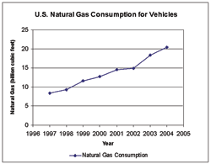

- CNG is available nationwide through a network of pipelines, there are approximately 1,200 CNG stations (Picture # 1) and you also have the option of installing a personal Natural Gas “Phil” unit into your home, slowly refueling you CNG vehicle. (Picture # 2)
Picture # 1 & 2
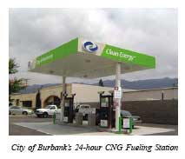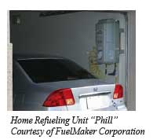

- As of July 2005 companies charged about $1.40 per therm of CNG, which is the equivalent $1.78 per gallon of gasoline.
- CNG vehicles will drastically cut down the carbon monoxide emissions by 90% to 97% and carbon dioxide emissions by 25%
- In a recent study the operating costs for CNG vehicles were 25% lower than that of gasoline vehicles.
- Many scientists believe that CNG is one of the most cost effective alternative energy sources to explore. Optimistically they say it begins to pay for itself immediately however more conservative researchers say within a year or two they pay for themselves.
Example- $200,000.00- cost of truck
+$50,000.00-to make it CNG compatible
-$32,000.00-tax credit for using alternative fuel
$18,000.00 – amount left over

$2.55- Average price for gallon of gas in Oxford
-$1.78- CNG Equivalent
$0.77 – Save per gallon of gas
x 12- Average number of gallons for fill-up
$9.24-Total saving at one fill-up
x 52- Number of weeks in the year
$480.48- Total annual savings if you fill up once a week

