Black Walnut
(Juglans nirga)
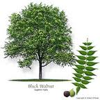

Life history
Confusion arises as to where the black walnut first originated. Historians believe the origin of the black walnut to be Persia somewhere between 8,000-2,000 BCE. However, the oldest archeological sight where walnuts were discovered is in the Shanidar caves in Iraq. The black walnut has been a staple for many cultures throughout history. American Indians utilized the tree for its nuts. They would eat them raw or pound them to form a type of “butter.” Indians also tapped the trunk of the black walnut for sap to make syrup. In France in 1663, during the famine, walnuts became a principal item. The poor used the walnuts as food and even resorted to grinding them up to make course bread. In the 1800’s, black walnut trees made their first appearance in the United States when they were brought from Spain.

Geographic range
The black walnut grows throughout the central and eastern parts of the United States, especially in the Appalachians and the Midwest. The black walnut is grown mostly in riparian zones (between land and river).

Size
The black walnut typically ranges from 50-75 feet. However, some trees can reach up to 130 feet or more.

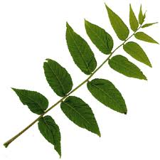Characteristics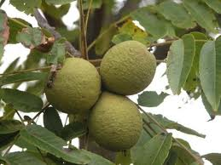
The black walnut has leaves that are alternately arranged and are pinnately compound. The leaflets are ovate-lanceolate shaped and sharply toothed. The stem has a light brown pith. The terminal bud is ¼- 1/3 inch long. The flower of the black walnut is terminal and in clusters of 2-5. Both male and female flowers are borne on the same tree. The black walnut fruit is a nut ranging from 1 ½ -2 inches in diameter. The nut is semifleshy and indehiscent.

Insect/fungal pests
Maggots are commonly knows to live in the husks of the black walnut, making the husks look unsightly. The walnuts can suffer from infestation of curculio, whose larvae can cause threatening damage to the nuts. Thousand cankers disease is a disease complex that has been looming in black walnut trees in several western states. The disease could have potential devastating effects if not controlled.

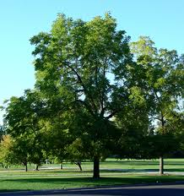

ECONOMIC IMPORTANCE
The black walnut is one of the most valuable timber trees. With its dark brown and hard strong wood, the black walnut has been the queen of American cabinet woods since the colonial days. It is also the leading gunstock wood and is used extensively in furniture manufacturing. The nuts have a sweet and distinctive taste that is in much demand for making cakes and candies.

Fun facts
The tallest black walnut tree sits on a residential property in Sauvie Island, Oregon. It is 8ft 7in in diameter, 112 ft. tall, and has a crown spread of 144 ft.

The black walnut is somewhat toxic. The roots and leaves of the tree secrete a substance into the soil called juglone. This substance serves as a repertory inhibitor to some plants, like white birch.

http://www.herballegacy.com/Berry_History.html
http://en.wikipedia.org/wiki/Juglans_nigra
The Illustrated Book of Trees-William Carey Grimm
The Illustrated Book of Trees-William Carey Grimm
http://en.wikipedia.org/wiki/Juglans_nigra
The Illustrated Book of Trees-William Carey Grimm
http://en.wikipedia.org/wiki/Juglans_nigra
http://en.wikipedia.org/wiki/Juglans_nigra Multiple Choice Questions: - The black walnut tree is the leading wood for what products? - Wooden shoes - Baseball bats - Gunstock and cabinets - Picture frames

